INTERNSHIP MANUAL

GUIDE FOR STUDENTI ONLINE – INTERNSHIP SECTION & FOR THE ACTIVATION OF THE INTERNSHIP AND THE INTERNSHIP FOR FINAL DISSERTATION

INTERNSHIP APPLICATION PROCEDURE SOL – INTERNSHIPS

STEP 1: HOW TO SUBMIT THE APPLICATION
- For internship with an external institution/company
- Accept the individualized offer proposed to you by the company/institution
- Submit the application for an internship offer already published by the company/institution of your interest
- Submit a self-application to the company/organization of your interest

- For internships at the University of Bologna
- Submit the internship application

- The Internship Office verifies the data entered, the Academic Tutor validates the internship programme, and the Internship Commission accepts the application (or requests its modification).

STEP 2: SIGNING OF THE INERNSHIP PROGRAMME AND PRINTING THE ATTENDANCE REGISTER
- Having received the approval of the Internship Commission, the student and the company/institution receive an email alert, asking to electronically sign the internship programme.
- After signing the internship programme online, the student must print the attendance register. The internship may begin from the date start indicated in the register.

STEP 3: COMPLETION OF THE INTERNSHIP
- Once you completed the required number of hours:
- On SOL Internships - click on ‘Manage the end of the internship’ and upload all the pages of the attendance register including all the signatures. The dates of obligatory interviews with the academic tutor (on 250th and 650th hour) must be also included.
- Fill out the mandatory online internship questionnaire.
- The Internship Office will verify and validate the attendance register.

STEP 4: VERBALIZATION
After the completion of the online internship, the activity must be registered on Almaesami by the Internship Commission. The procedure of the internship registration on Almaesami are determined by Internship Commission of a given degree programme. To find out more, visit the Internship section of your degree programme website.

RESPONSE TO AN INTERNSHIP OFFER
(offer made by the company/institution to search for trainees, which can be addressed to students of particular degree program or programs)
- On SOL – Internships go to: Offers → Curricular Internship → Select the desired offer → Submit application
- Enter the name of your Academic Tutor
- For Curricular Internships: You don’t have to enter the name of your Academic Tutor, as it will be entered by the Internship Office
- For Internships for Final Dissertation: The Academic Tutor is concurrent with your Thesis Supervisor
If you wish to self-apply for the internship, upload your CV and covering letter merged in a single pdf file.
- Click on ‘Send the request’
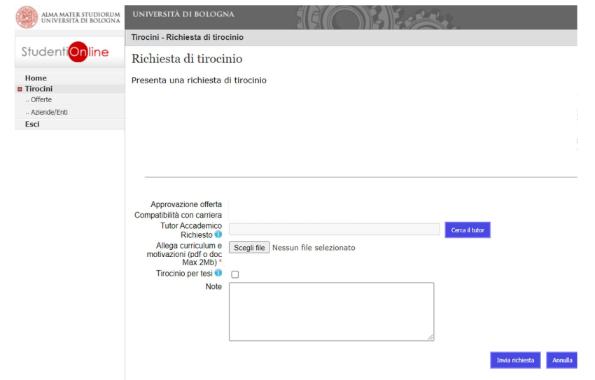
RESPONSE TO AN INDIVIDUALISED INTERSHIP OFFER ‘AD PERSONAM’
(offer proposed to a student already chosen by a given company/institution)
- On SOL – Internships go to: Offers for ‘ad personam’ internship → Choose the offer addressed to you → Click on ‘submit the request’
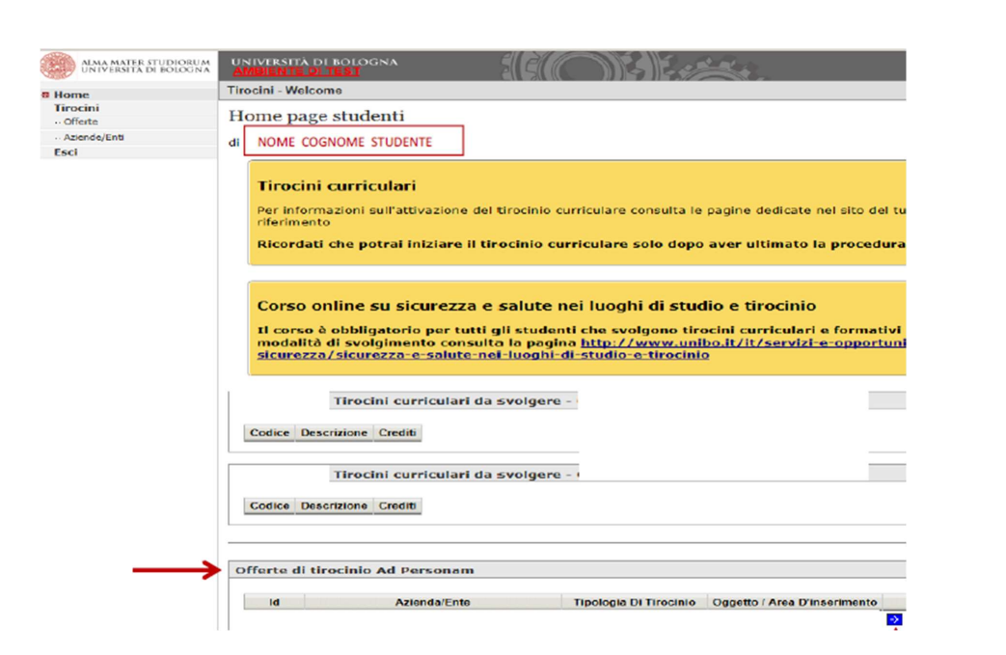
- The same window that shows for the open internship offers will show (section above). Click on ‘Send the request’ (it is not necessary to upload the CV).

SELF-APPLICATION FOR THE INTERNSHIP
- On SOL – Internships go to: Companies/ Institutions – you will see the complete list of institutions that accept self-application, sorted by the field of study and location.
- Select the institution of your interest to see the details and submit the self-application.
- Select Curricular internship to access the internship request window.
NB It is not necessary to indicate the name of your Academic Tutor.
- Click on ‘Send the request’.

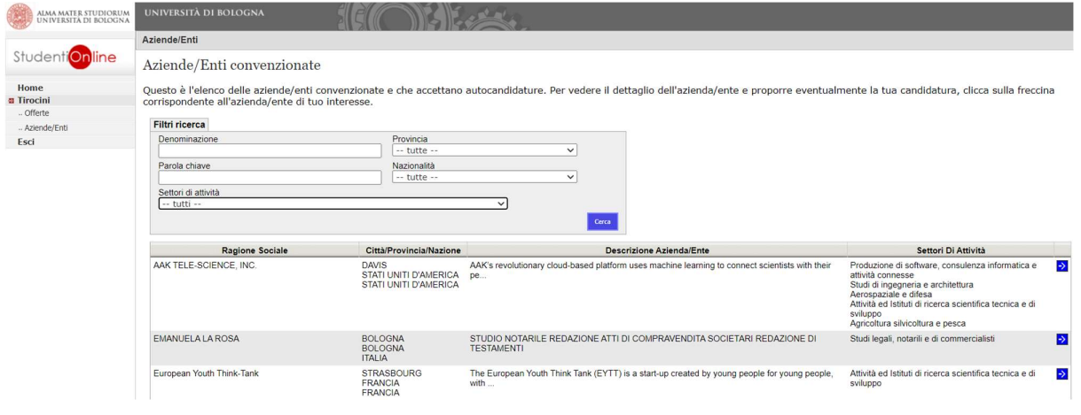

INTERNSHIP AT THE UNIVERSITY OF BOLOGNA
- Having agreed on the aims and activities, that you will carry out during the internship, with the Academic Tutor and the Tutor from the host institution (they can be the same person), select ‘Alma Mater Studiorum Università di Bologna’ as the company/institution at which you will carry out the internship.
- Click on ‘Submit the request’.
- Fill in the required data and send the request.

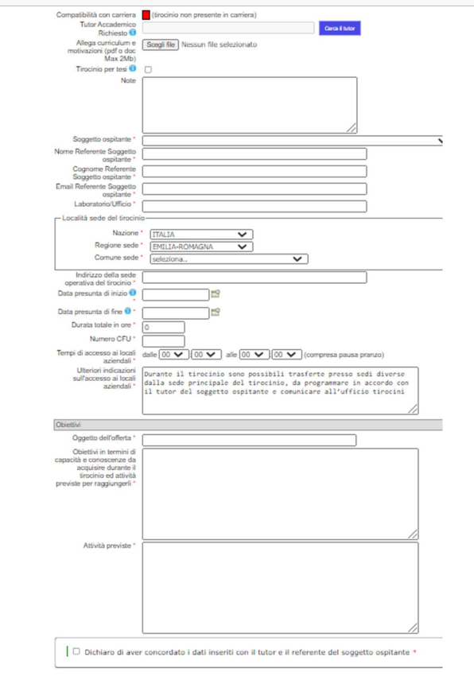

Data of the institution/ company and the name of the Tutor from the host institution.

The number of credits (CFU), indicated in the course structure diagram, determines the duration of the internship.
1 CFU = min.25/max.30 hours
Describe in detail the educational objectives and activities planned, in accordance with the Tutors, to be carried out during the Internship

